**CURRICULUM VITAE**



**RICHARD BRACERO**

Poblacion, Madridejos, Cebu, Philippines

Cellphone Number: +639298414660

[drahcirbracero@gmail.com](mailto:drahcirbracero@gmail.com)

**PERSONAL INFORMATION:**

Age              : 23 years old

Date of Birth    : April 16, 1998

Place of Birth : Tabunok, Sogod, Cebu

Sex             : Male

Civil Status      : Single

Religion          : Roman Catholic

Height           : 5’8”

Weight           : 172 Lbs.

**EDUCATIONAL BACKGROUND**:

**College Education**:  Madridejos Community College

                   Crossing Bunakan, Madridejos, Cebu

                    2018-2019

**High School:** Calumboyan National High School

                   Calumboyan, Sugod, Cebu

                    2014-2015

**Elementary Education**: Tabunok Elem. School

                     Tabunok, Sugod, Cebu

2010-2011

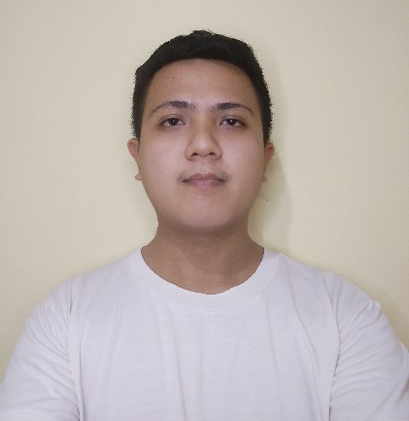**MARK LOUIS E. CORNEA**

Tugas, Madridejos, Cebu, Philippines

Cellphone Number: +639302566284

[markcornea@gmail.com](mailto:markcornea@gmail.com)

[louiscornea@yahoo.com](mailto:louiscornea@yahoo.com)

**PERSONAL INFORMATION:**

Age : 21 years old

Date of Birth : January 9, 2000

Place of Birth : Koronadal, South Cotabato

Sex : Male

Civil Status : Single

Religion : Jehovah’s Witnesses

Height : 5’7”

Weight : 140 Lbs.

**EDUCATIONAL BACKGROUND:**

**College Education**:  Madridejos Community College

                   Crossing Bunakan, Madridejos, Cebu

                    2018-2019

**Senior High School**: Madridejos Community College

                   Crossing Bunakan, Madridejos, Cebu

                    2017-2018

**Junior High School**: Madridejos National High School

                   Poblacion, Madridejos, Cebu

                    2015-2016

**Elementary Education**: Madridejos Central Elem. School

                     Poblacion, Madridejos, Cebu

2011-2012



**VINCENT Y. SEVILLENO**

Tugas, Madridejos, Cebu, Philippines

Cellphone Number: 09704629255

[sevillenovincent@gmail.com](mailto:sevillenovincent@gmail.com)

[Vincentsevilleno@yahoo.com](mailto:Vincentsevilleno@yahoo.com)

**PERSONAL INFORMATION:**

Age                 : 22 years old

Date of Birth  : May 03, 1999

Place of Birth : Kangkaibe, Bantayan, Cebu

Sex               : Male

Civil Status     : Single

Religion          : N/A

Height           : 5’5”

Weight             : 162 Lbs.

**EDUCATIONAL BACKGROUND:**

**College Education**:  Madridejos Community College

                   Crossing Bunakan, Madridejos, Cebu

                    2018-2019

**Senior High School**: Madridejos National High School

                    Poblacion ,Madridejos, Cebu

                   2017-2018

**Junior High School**: Madridejos National High School

                   Poblacion, Madridejos, Cebu

                    2015-2016

**Elementary Education**: Madridejos Central Elem. School

                     Poblacion, Madridejos, Cebu

2011-2012

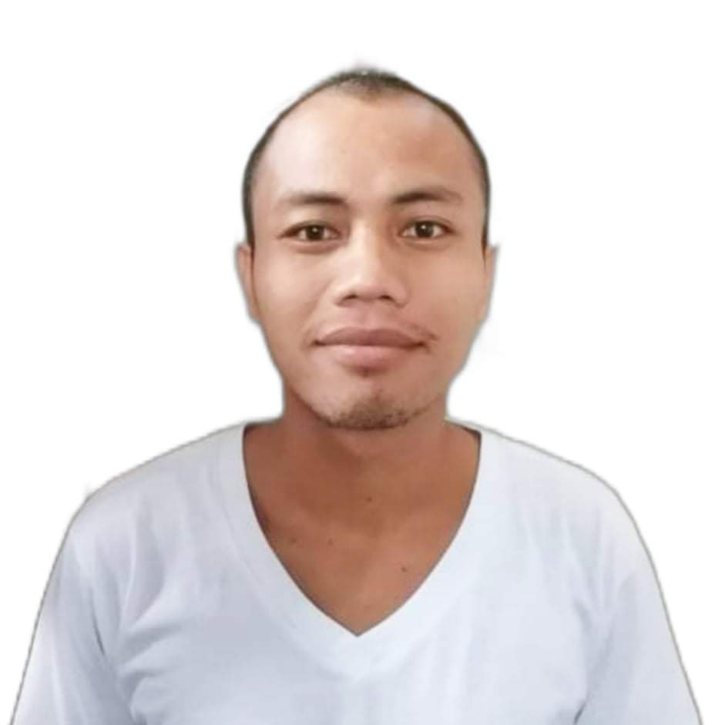

**JUPRIL P. QUIAMCO**

Talangnan, Madridejos, Cebu, Philippines

Cellphone Number: +63 950 495 2600

[Juprilquiamco123@gmail.com](mailto:Juprilquiamco123@gmail.com)

**PERSONAL INFORMATION:**

Age                 :  24 years old

Date of Birth    :  April 22,1997

Place of Birth :  Talangnan, Madridejos, Cebu

Sex                 :  Male

Civil Status       :  Single

Religion            :  Iglesia Ni Cristo

Height              :  5’6”

Weight              :  163 Lbs.

**EDUCATIONAL BACKGROUND:**

**College Education:**  Madridejos Community College

                    Crossing Bunakan, Madridejos, Cebu

                   2018-2019

**High School:**  Madridejos National High School

                   Poblacion, Madridejos, Cebu

                    2012-2013

**Elementary Education**: Sentral Elementary School

     Poblacion, Madridejos, Cebu

                     2008-2009



**RANIE JOY A. HIJAPON**

Mancilang, Madridejos, Cebu, Philippines

Cellphone Number: 09658245473

[raniejoy.hijapon05@gmail.com](mailto:raniejoy.hijapon05@gmail.com)

**PERSONAL INFORMATION:**

Age             : 23 years old

Date of Birth  : May 14, 1998

Place of Birth : Ocoy, Santa Fe, Cebu

Sex               : Female

Civil Status      : Single

Religion          : IFI

Height           : 5’1”

Weight             : 59 Lbs.

**EDUCATIONAL BACKGROUND:**

**College Education:**  Madridejos Community College

                   Crossing Bunakan, Madridejos, Cebu

                   2021-2022

**Junior High School:** Santa Fe National High School

                  Poblacion, Santa fe, Cebu

                   2014-2015

**Elementary Education:** Ocoy Elementary School

                     Ocoy, Santa fe, Cebu

                     2010-2011



**RENE JUN C. TAES**

Talangnan, Madridejos, Cebu, Philippines

Cellphone Number: 639093105893

[junjuntaes44@gmail.com](mailto:junjuntaes44@gmail.com)

**PERSONAL INFORMATION:**

Age                 : 21 years old

Date of Birth    : February 11, 2000

Place of Birth : Botigues, Bantayan, Cebu

Sex                : Male

Civil Status        : Single

Religion            : Iglesia Ni Cristo

Height              : 5’4”

Weight              : 158 Lbs.

**EDUCATIONAL BACKGROUND:**

**College Education:**  Madridejos Community College

                   Crossing Bunakan, Madridejos, Cebu

                    2018-2019

**Senior High School:** Madridejos National High School

                    Poblacion ,Madridejos, Cebu

                   2017-2018

**Junior High School:** Doong National High School

Poblacion, Madridejos, Cebu

                    2015-2016

**Elementary Education:** Botigues Elem. School

                     Botigues, Bantayan, Cebu

2011-2012